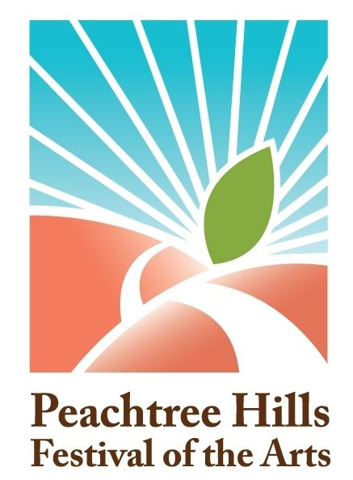
The Atlanta Foundation for Public Spaces is proud to announce the judge for the 2014 Peachtree Hills Festival of the Arts: Thomas Deans of Thomas Deans Fine Art.

Judging will take place on Saturday, May 31 at noon. Awards will be presented in the following categories:

Best of Show: Fine Arts
1st Place (over all)
2nd Place (over all)
3rd Place (over all)
Best of Show: Craft
Honorable Mentions (2)
Best Booth
Director’s Choice
Friends of the Festival

ABOUT THOMAS DEANS
With a strong academic background in the arts, Thomas Deans has lectured and written on the fine and performing arts for schools, museums, and opera and ballet companies across the United States and in the UK. He has provided chapters on British artists for the catalog of the collection of the St. Petersburg Museum of Fine Arts and for Margaret Barlow’s Women Artists, 1999.

ABOUT THOMAS DEANS FINE ART
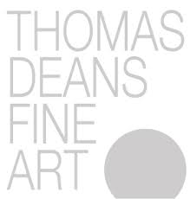
Thomas Deans Fine Art was established in 1983 and during the following decade became known as one of the leading American specialists in British art on paper from the great age of watercolor, 1750-1860. Since the turn of the century, the gallery has continually expanded its inventory and exhibitions to include an eclectic and varied presentation of modern and contemporary art in a variety of media by American and European artists, ranging from mid- and late-career masters of international reputation. Beginning in 2004, the gallery added contemporary photography to its exhibitions of works on paper. Since 2011, the gallery has occupied premises on Miami Circle, one of Atlanta’s premier art and design districts.

Thomas Deans Fine Art
www.thomasdeansfineart.com

